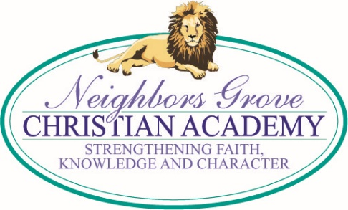
TUESDAY MEMO
1/30/18

FEBRUARY ~ OPPORTUNITY SCHOLARSHIP GRANT MONTH

New and renewal applications must be completed in February in order to be on the priority list! If you know of any families who could benefit from this program, please pass the word along. For more information and the online application go to www.ncseaa.edu/OSG.htm. A detailed information sheet is attached. Please read it carefully for yourself so you can explain the program to friends and family. We have several students already benefiting from these scholarships.

YEARBOOK ORDERS AND DEDICATIONS
Yearbook order and dedication page forms went home last week and are available on the website. If you would like to order a yearbook or place an ad please submit your order form by March 16. Yearbooks ordered after March 16 will cost $4 0 each. ALL YEARBOOKS MUST BE ORDERED IN ADVANCE THIS YEAR. THERE WILL BE NO EXTRA YEARBOOKS ORDERED.

2018-2019 SCHOOL CALENDAR

Next year's proposed school calendar will be presented to the Christian Education Center Board next Tuesday, Feb. 6. We would like to give you the opportunity for input on next year's Easter/Spring Break. Easter comes late next spring so if we take Easter Week, April 22-26. our break will be very late in the semester. County and City schools are taking the week before Easter, April 15-19, which makes it slightly earlier. Since we have normally taken the week beginning with Easter, we wanted to give you an opportunity to share your preference. Our current thought is to switch to the week before Easter, taking the same week as the County and City schools. You may call or email the office with your thoughts. Thank you!

SPIRIT WEEK PROJECT ~

This year we will be raising money for children in Sierra Leone, Haiti and the Philippines who are awaiting regular sponsors through the World Hope International Child Sponsorship program. These funds will enable them to attend school and also provide food. Each student will receive a small bank to bring home to begin saving toward Spirit Week. The fundraising campaign is called the “5&2 Challenge,” praying that as Jesus multiplied the 5 loaves and 2 fish to feed the multitude, so He will bless and multiply these offerings and their benefit for a multitude of children. Please begin collecting coins & bills but hold the banks at home until Spirit Week. Why not let your children do some extra things to earn additional monies for a great need!

World Hope International is a Christian relief and development organization working with vulnerable and exploited communities to alleviate poverty, suffering and injustice. In their words, “We work in 15 of the poorest countries in the world, helping all people, regardless of ethnicity, gender, race or religion. We serve the poorest of the poor, those crippled by a lack of opportunity. We put children first, because we believe that when you empower the youngest generation, you invest in future leaders. Leaders who will ensure their children grow up in a world with opportunity, dignity and hope.” The Wesleyan Church often partners with this excellent relief organization. Much more information is available at www.worldhope.org.

YEARBOOK

If you have pictures that we could use for the yearbook, please email them to ngcayearbook@gmail.com.

NC OPPORTUNITY SCHOLARSHIP GRANT RENEWAL

All those who are receiving the OSG should be checking their email for renewal information.

ACHIEVEMENT TEST WEEK
Please do not schedule doctor and dentist appointments before lunch the week of April 23-27. Achievement tests are very difficult to make up. Thank you!

UPCOMING DATES

Feb 13 – Progress Reports Feb 19 – Presidents’ Day
Feb 26 – Mar 2 – Spirit Week Mar 15-24 – Book Fair
Mar 16 – Grandparents’ Day, 10 am Mar 16 – End of Quarter, Noon Dismissal
Mar 20 – Report Cards Mar 24 – Spaghetti Dinner
Mar 30 – Good Friday Apr 2-6 – Spring Break
April 23-27 – Achievement Testing May 10 - Spring Concert
May 28 - Memorial Day May 30 - May Fun Day @ VMC
May 31 - Pre-K and Kindergarten Graduation Jun 1 – Awards Assembly, 9:30 am
Jun 1 – Graduation, 7 pm

