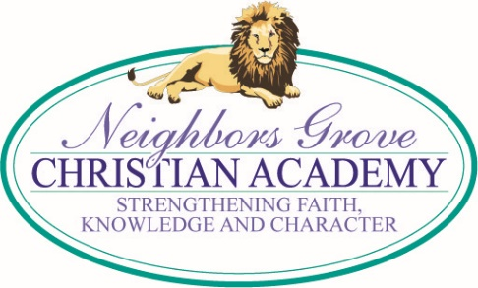
TUESDAY MEMO
11/28/17

CHRISTMAS CONCERT ~ THURSDAY, DEC 7
Students are getting excited about the upcoming concert. Private lesson students should be working hard on their individual pieces also. Dress Code is no jeans, shorts or tennis shoes. Christmas colors are preferable. Dresses and skirts must be no more than 2 inches above the knee when standing, per our regular school dress code.

BOOK FAIR SALES RESULTS
We sold a total of $2,218 in our fall Book Fair! Teachers were given books for their classrooms totaling $160 in Scholastic Dollars. Mrs. Heppding’s class won the elementary sales contest with their total sales coming to $627. Ms. Ashley’s four-year-old class won the daycare sales with $342. Thank you to everyone who purchased books and/or worked during the Book Fair!

CHILI DINNER
Thank you to everyone who worked and sold tickets for our Chili & Baked Potato Dinner. We ended up with a profit of $1,645!

CHICK-FIL-A NIGHT ~ DEC 11
Mrs. Leveille’s class is hosting the Chick-Fil-a for December. Please come out and enjoy a time of food and fellowship. The individuals signed up to work the registration table are: Jennifer Needham from 5-6 pm, Rebecca Wooters from 6-7 pm, and Julie Mason from 7-8 pm.

CAMRIN KEENE MEMORIAL GIFTS UPDATED
Total memorial gifts to date are $1,325. We have been able to find two of the commercial picnic tables for about $1,750 including shipping. We would love to reach this goal before Christmas. All checks should be made to NGCA and are tax deductible. A list of donors (without gift amounts) will be shared with the family. Thank you for helping us honor the memory of Camrin.

DISCOUNT CARD/PRETZEL & CHILI TICKET MONEY DUE ASAP

UPCOMING DATES

Nov 28 – Progress Reports
Dec 7 – Christmas Concert (All School)
Dec 13 – CARE Graduation
Dec 20 – Last Day, Early Dismissal
January 2 – Students Return

