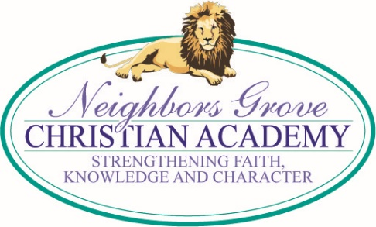
TUESDAY MEMO
2/27/18

GRANDPARENTS’ DAY IS COMING UP!

We will be celebrating Grandparents’ Day at NGCA Friday, March 16. Parents, please help your child mail or hand deliver the invitations to this special program followed by a visit to your child’s classroom. Three invitations per family are being sent home, but additional ones are available from the office. The 10:00 program in the sanctuary will be about 40 minutes, followed by light refreshments in the classrooms where the children will be delighted to show grandparents some of their school work and class activities. A personal note added to the printed invitation would make it special! Also, your assistance is providing light refreshments would be greatly appreciated! Contact your child’s teacher for how you can help.

SPIRIT WEEK UPDATE

Spirit Week has gotten off to a great start with almost 100% participation with students and teachers! We wish you could see and feel all of the excitement each morning! After a slow start with project monies on Monday, we started picking up the pace today! Our giving total is now $206.08. Let’s see how much we can do to help children attend school and have a decent meal each day in Sierra Leone, Haiti, and the Philippines; not to mention what the kids would like to do to Mr. Haithcock! (See article below.)

SPIRIT WEEK COMPETITION INFO

To add to the fun and excitement of Spirit Week, classes will be in competition with each other - elementary classes against each other and middle/high classes against each other. Classes will be judged each day for participation, effort and creativity with the daily dress-up themes, also their decorated doors on Friday are judged, plus points for games and their participation in giving toward the Spirit Week project, "5&2 Challenge." Besides receiving points toward winning the overall competition prize - Bounce House for elementary, and lunch out and movie for middle/high, offerings will also give students the chance to cover their teachers with silly string!

For every $100 brought in, 1 teacher’s name and 10 students’ names will be drawn. Those 10 students will get to silly string that teacher.

That means…

$200 = 2 teachers & 20 students

$300 = 3 teachers & 30 students

$400 = 4 teachers & 40 students

$500 = 5 teachers & all students

And best of all:

This year we decided to go big or go home when it came to what we could do to Mr. Haithcock for reaching our goals. So here it is: if we reach $1,000 we will dye his hair purple that afternoon; if we reach $1,250 we will dye his hair purple AND cover him in purple slime; and if we reach $1,500 we will dye his hair purple, cover him in purple slime AND turn him into a human ice cream sundae!

SPIRIT WEEK DAILY THEMES
Get ready for Feb. 26- Mar. 2! Theme Days: Monday - School Spirit Day, Tuesday – Tacky Tuesday, Wednesday – Time Warp Wednesday, Thursday – Character Day, and Friday – Team Choice.

PARENTS OF 4TH AND 5TH GRADERS

NGCA has the opportunity to sing a requested song, "We Are The World,"(remember the 80's?) for a Ladies Luncheon at Pinewood County Club, April 19. This is a major fund raiser for the Randolph County Family Crisis Center. The students have received lyrics and a CD to practice at home. There will be auditions for solos on the verses.

FEBRUARY ~ OPPORTUNITY SCHOLARSHIP GRANT MONTH

New and renewal applications must be completed in February to be on the priority list! If you know of any families who could benefit from this program, please pass the word along. For more information and the online application go to www.ncseaa.edu/OSG.htm. A detailed information sheet was distributed last week. Please read it carefully for yourself so you can explain the program to friends and family. We have several students already benefiting from these scholarships. The information sheets are available in the office or on the website.

YEARBOOK ORDERS AND DEDICATIONS
If you would like to order a yearbook or place an ad, please submit your order form by March 16. Yearbooks ordered after March 16 will cost $40 each. ALL YEARBOOKS MUST BE ORDERED IN ADVANCE THIS YEAR. NO EXTRA YEARBOOKS WILL BE ORDERED. Yearbook order and dedication page forms are available in the school office or on the website under “Latest News” page 2.

YEARBOOK

If you have pictures that we could use for the yearbook, please email them to ngcayearbook@gmail.com.
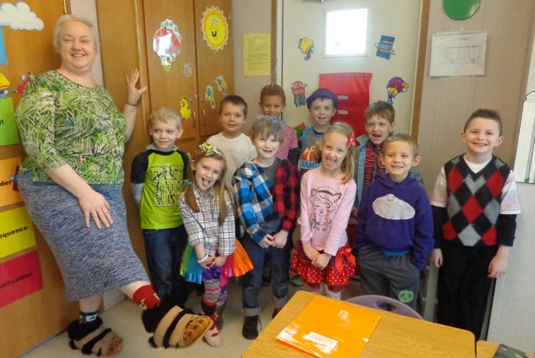

UPCOMING DATES

Mar 15-24 – Book Fair
Mar 16 – Grandparents’ Day, 10 am
Mar 16 – End of Quarter, Noon Dismissal
Mar 20 – Report Cards
Mar 24 – Spaghetti Dinner
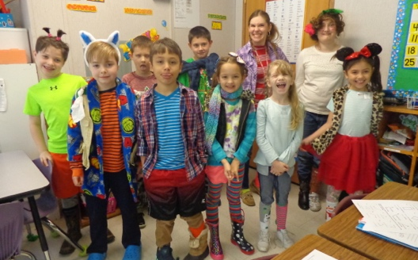
Mar 30 – Good Friday
Apr 2-6 – Spring Break
April 23-27 – Achievement Testing
May 10 - Spring Concert
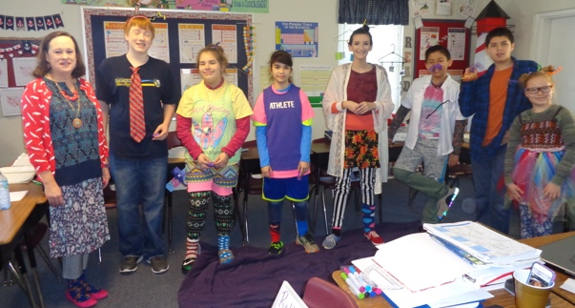
May 28 - Memorial Day
May 30 - May Fun Day @ VMC
May 31 - Pre-K and Kindergarten Graduation
Jun 1 – Awards Assembly, 9:30 am
Jun 1 – Graduation, 7 pm

