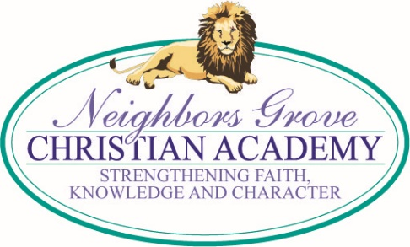
TUESDAY MEMO
9/12/17

PTM NEEDS YOUR DISCOUNT CARDS & PRETZEL MONEY
The PTM has a large bill due this week for the cards and pretzels. Please bring in your money as soon as possible – and keep selling! Thank you!

HURRICANE RELIEF
One of our parents, Ray Read, and truck driver, Tom Bell, arrived home Sunday from taking 27,000 lbs. of relief supplies to the Houston, Texas area. These supplies came from NG Church and many people throughout the community. The Lone Star Cowboy Church that was distributing supplies to the community was so grateful to have their empty pantries refilled. You can friend Ray on Facebook and see video.
We now have a full size trailer to fill with needed supplies for Irma victims in Florida. Any of the items you hear advertised on the media and nonperishable food are welcome and needed. If no one is on hand at the trailer to receive your donations, you may leave them at the church steps, or in the hallway if it’s raining. If you would help us advertise this at your church and work places, we would be grateful. Thank you!

PRAYER REQUEST
Please be praying for Yareni and Yasir’s mother, Yareni, who is scheduled for surgery Thursday to have 2 tumors removed.

SEE YOU AT THE POLE ~ SEPT 27 @ 9:00AM
NGCA students will be performing for this special event and together we will pray for our community and nation. We are also particularly inviting all available First Responders and will be expressing our appreciation to them and praying for them. Families and friends are invited. We will be in the parking lot. Feel free to bring chairs if standing is difficult. The meeting should be about 20-25 minutes.

YANKEE CANDLE FUNDRAISER
The middle and high school student will continue their Yankee Candle Catalog orders through 3 pm, next Tuesday, September 19. Online orders will continue through January 10, 2018. Students are raising funds for their spring field trips. Online group # is 990104327.

PARENTING HELP
You will find some very interesting and helpful Q & A in this month's Rosemond newsletter attached to the email or found at www.rosemond.com/September-2017.html

UPCOMING DATES
Sept 19 – Progress Reports Sept 27 – See You At The Pole
Oct 4 – Picture Day Oct. 11 – Last Day of 1st Quarter
Oct. 12, 13 – ACSI Convention, No School Oct 16 – Teacher Workday
Oct 17 – Parent Conferences, No School Nov 22-24 – Thanksgiving Holiday
Nov 28 – Progress Reports

